New Dis-Eur-France-Le Grand Pressigny-Side Burin-2400-2000 BCE

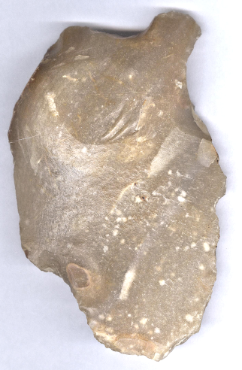 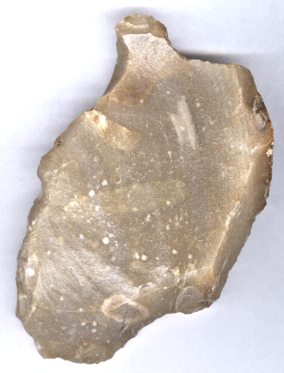

**Formal Label:** Le Grand Pressigny, France, Neolithic Burin-2400-2000 BCE

**Accession Number:**

**Display Description:** The Grand Pressigny is the eponymous name of a Neolithic flint industry known since 1863 for its tools, which are expertly flaked from a "butter pound" shaped core. This burin is an example of a tool made from a Grand Pressigny large, thick flake that was discarded and then manipulating the discarded flake into a short piece with a large, deep facette struck on its edge to produce the burin.

**LC Classification:** GN776.22.F7

**Date or Time Horizon:** 2400-2000 BCE

**Geographical Area:** Le Petit Pressigny

**Cultural Affiliation:** French Neolithic

Map, GPS:

**Medium:** Le Grand Pressigny Flint

**Dimensions:   
Weight:**

**Provenance: from an** old Belgian collection.

**Condition:** original.

**Discussion:** The manufacture of this burin from Le Grand Pressigny flint was probably from a local area around the quarries and not for trade.

**References:**

Louboutin, C. 2011. Archeology of the Touraine. Éditions La Simarre

Steenstrup and John Lubbock. 1867. “On the Flint Implements Recently Discovered at Pressigny-le-Grand,” *Transactions of the Ethnological Society of London*, 5: 221-227.